*JI*

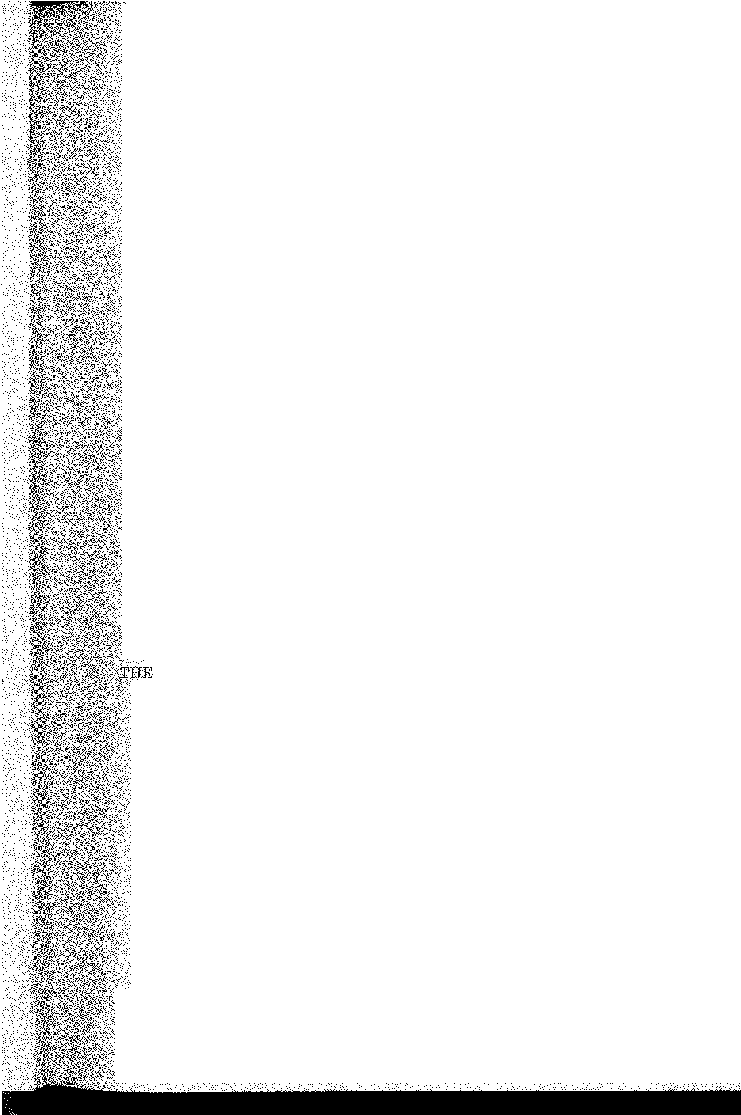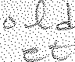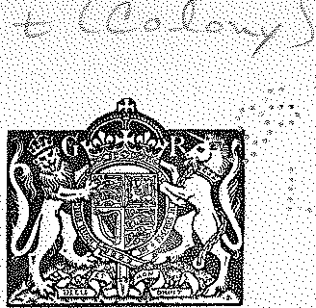

# 11HE LAWS

OF THE

# GOLD COAST COLONY

CON'l'AININ'G

## THE ORDINANCES OF THE COLONY AND THE ORDERS, PROCLA1IATTONS, REGULATIONS, RULES AND BYE·LAWS MADE THERE UNDER

IN FORCR ON

### THE lsT DAY OF JANUARY, 1928,

TOGF,THBR WITH TRlC:

## LETTERS PATE NT AN D ROYAL INSTRUCTIONS AND THE PRINCIPAL IMPER IAL STATUTES AND O RDERS OF THE OVEREIGN-IN-COUNCIL RELATING TO THE COLONY.

### REVISED EDITION.

l'nRPARED 'UNDER THE AtJTtroRI't't OT'

RF.VISED EDI11ION OF THE LAVVS ORDINANCE, 1928,

DY

### ERNEST GARDINER SMITH, M.A., LL.B.

ADVOCATR,

*A P-11'/.me Jurlqr, of the Snpt·eme Court of the Golt/. Onast (Jolony.*

IN THREE VOLUMES :

VOL. I.

OON'rAINING 'fffg 0RDINANCES 1 0HAI'TBRS 1-107.

**A** to **Mi.**

*P11bli- l!rd frrr tlir G01Hwmnrnt of the Gold Coast by the Ot·own .Aqent.'i .f M' the Cnlo!!i('S, 4, Jl:lillbank , London,, S.W.1.*

**PRICE** £6 6s. Od. per set of 5 vols.

PRINTED **BY**

WATERLOW & SONS LIMITED, LONDON WALL, LONDON.

**1928.**

*Appointed h!f the Gov Arnnumt of the Gold Coast Colony the G'overnment Printer of fkM Edition*

*witkin the ·mNmfog of thr Evidence (Colonial Sfot-utes) Act , 1907-)*

*CRIM INAL CODE.* **[CAP. 29.** 353

gold and silver in dust, solution, or otherwise, as aforesaid, after they have been produced in evidence, or when they have been seized and are not required to be produced in evidence, shall be forfeited and applied as the Comt directs.

**Book 2.**

**Part 6**

**Titlo 1 3.**

**122.** Whoever, without lawful authority or excuse (the Having

proof whereof shall lie on him), has in his custody or

**possession of**

moro than

possession any greater number of pieces than five pieces of five piec"' of

fa1se or counterf 81·t com.

resemblm'

g, or apparently m. tended

fcooruenigtenrfceoitin,

to resemble or pass for, any gold or silver coin of any foreign &o. prince, state, or country, or any kind of coin not being the King's current coin, but resembling, or apparently intended

to resemble *or* pass for, any copper coin, or any other coin made of any metal or mixed metals, of less value than the silver coin of any foreign prince, state, or country, shall, on being convicted thereof , forfeit all such false and counter- feit coin (which shall be cut in pieces or otherise destroyed by order of any District Commissioner), and shall, for every such offence, be liable to a fine of two pounds for every such piece of false and counterfeit coin which is found in his custody or possession.

PART 6.-0FFENCES AGAINST PUBLIC ORDER, HEALTH, AND MORALITY.

TITLE 13.-PUBLIC NUISANCES.



#### Drumming and firing guns, &c.

1. (1) Every occupier of any house, building, yard or other place situate in any town, who, without a licence in writing from the Governor or a District Commissioner, permits any persons to assemble and beat or play or dance therein to any drum, gong, tom-tom, or other similar instrument of music, shall be liable to a fine of two pounds.
   1. It shall be lawful for any constable to enter any such house, building, yard, or other place where any persons may be so assembled, and to warn them to depart and to seize and carry away all such drums, gongs, tom-toms, or other instruments, and the same shall be forfeited.
   2. Whoever, after being so warned, shall not depart forthwith (except the persons actually dwelling in such house or building), may be apprehended, without warrant, by any constable or person acting in his aid, and shall be liable to a fine of ten shillings.

**VOL, I-23.**

**AUowing house, &a., in town to be used for drumming. *( SP.<'* e. 142**

(IO).)

3M

nook- *2.*

*Port 6:*

Tit!e.· 13: ·

Drumming, &c,) near court. dur.ing

.sit._ting,

DruIDiufug with intent to chalfongt\

*or* insult. '

DJ,w_ha.J'girtg guris. &c,,

,in town.

Stray·cO:litle,

CAP, 29.1 *CRIM I N AL CODE:.*

1. Whoev.er during the sitting of a court, and after being warned by a constable or officer of the court todesist, beats or plays any drum, gong, tom-tom or other instrument, or makes any loud noise of any kipd within a radius of three hundred yards. from. the place where such sitting is held, shall belia ble to a fine of two pounds,

**15.** Whoever beats a drull'.l with, intent to challenge or provoke anyother person to commit a breach of the peace, orwith intent. to.irnmlt or. an110y any other person, shall be liab.le to a fine oE twenty-tlve poumls orto imprisonment for three months.

**126.** \Vhoevm: inany tovin without lawful amlncccssary

occasion :---

(1) l)ischarges any firearm, or tln:ows or sets fire to any firework in any publiQ place, or in nny house, building; or yard ; or

. (2) Being the occupier of any house, building, or yard, kno'lvingly permits any fir1carm to.be discharged therein

shall be liable to a fine of ten pounds.

#### Stray cattle, rnad .doy8, &Jc,

in**127.\*** (1) If in any town, any cattle. ainm found at]arge

a11y public place. without any person charge thereof,



any peaee officer or health officer or inspector or assistant i:hll.pectQr of nuisHJnces may seize and impound such cattle in any comn:rnn pound, and may detain the same therein until the ownerthereof pays to the Treasury a fine of not Jess than . five shillings and not exeecling ten shillings per head besides. th() expenses .of keeping the same at rates not exc.eecling sixpence a•day for each head of swine, sheep or goats, and one shilling a day for each head of other cattle. *( As am.e1uler.l by* 38 *of* 1924, *s.* 4 **(1).)**

(2) If the said fine and expenses a!'e not paid within four dayBaftersuchirnpounding,,the po1md keepe1', or other person l'J):r,Ointed by thehealth officer for the purpose, may sell ;i,nv sucn cattle ;. b1:tt, previous tosuch sale, six d avs' rwtioe thereof.shall be given or left at the dwelling-house of the mvner he is·known, or, if not,.then the notice shall

be if

conspicuously po5ted in some·usual place for the posting·.

*- But wh_en ·a. owri council is oStablished, *_.se* se-0, 40 Of- Cap. 167.

*CRIM INAL CODE.* **[CAP. 29.** 359

(2) For the purposes of this section, harm shall in this case be deemed to have been caused by the act, although the harm be the mere inward effect of the terror caused bv the act. "

*Tll1tstrations.*

. *(a) A.* goes about the streets, or *in* a cemetery at night, dressed up in a white sheet m owler to pass for a, ghost. H any person is thereby seriously frightened and ma<lc ill or insane, *A.* is guilty of an offence against this section.

1. *A.* lets off a firework in a crowd. Although he may not have actually purposed

to cause harm to any person, yet, if any person is injured by fright or by the movement of the crowd in consequence of the explosion, *A.* is guilty of an offence against this section.

1. *A.* wilfully raises a false a,1arm of fire in a theatre, and a panic ensues in which

a person is injured, *A.* is guilty of an offence against this section.

*N nisam.ces cmd obstru.ctions in streets, and the Zike.*

1. Whoever does any of the following acts shall be liable to a fine of forty shillings, namely :-
   1. In any town places, or causes or permits to be placed, any carrion, filth, dirt, refuse or rubbish, or any offensive or unwholesome matter, on any street, yard, enclosure, or open space, except at such places as may be set apart by the District Commissioner or the health officer for that purpose ; or

Book 2.

Part 6.

Title 13.

*(See s.* 223_ \

Throwing rubbish in street.

(2) In any town commits a nuisance in any public Noisanees. place or open space, or in any place being an appurtenance of or adjoining a dwelling-house ;

or

(3) Wilf ully defaces any public lawful notice, or Defacing

removes the same from any place where it is public notice.

lawf ully affixed ; or

1. Without the consent of the owner or occunier thereof affixes or attempts to affix any placird, paper, or thing on any building, wall, f ence, pillar, or post, or writes upon, soils, or marks any such building, wall, fence, pillar, or post ; or



1. vVithout due authority affixes or attempts to affix any placard, paper, or thing on, or writes upon, soils, or marks any post office or post office letter box ; or

(6) Unlawfully releases any cattle lawf ully impounded, or pulls down, damages, or destroys the pound wherein any cattle are lawf ully impounded ; m

(7) In any public place is drunk and behaves violently or indecently ; or

Defacing building, &c.

Dofa,cing

post office or letttn: box.

Pound

breaeh.

I{eing drunk a nd dis orderly.

360 **CAP. 29,}** *ORIMINAL OODE.*

llook *2.*

P•rl 6.

Titlo 13.

Fighting,: iu pubJfo=

·pta.ce.

ShOUting -&c.

1n town,

Drumming

,tri,,:in town at_·night."

*{See s:* _-12-3:'}

(8) In any public place, or in any place .within sight or hearing of persons then. being in a public place, disturbs the peace by fighting or quarrelling with any other person ; or abets an unlawful fight ; or 1ses or a;pplies to any other person then being in such public place or within sight or hearing thereof, any violent or. abusive term .of reproach ; or sings any . profane, indecent, or obscene song ; or exposes any defamatory or insulting writing or object ; or with the intention of annoying or irritating any other person, sings any scurrilous or .abusive song or . words, whether any person be particularly addressed therein or not ; or is guilty . of any riotous, indecent, . disorderly, or insulting behaviour, to the .· obstruction or annoyance 0£ ' any. passenger or ·person in such public place ; or

(9)In any town "INilfully or wantonly, and after being warned to desist, shouts or blows any horn or shell, or . sounds or plays upon any musical instrument, or sings or makes any other loud or u:hseemly noise, to the annoyance *or* disturb­ ance of any person ; or

**(10)** In any town, without a licence in writing from the Governor or a District Cornmfasioner, beats. or plays any dn1m, gong, tom'tom, or other similar instrument . of music. between eight o'clock at ,1ight and six in the morning ; or

·T!rrowirig

st.Ones, _&0.

(11)

In. any town throws or discharges any stone or other missile in or into any public place ; or

Behavm,r

_vio1ent1i1n

priS<m;"·&o.

· J&e s. 377.}.

Behaving i;rre'Zerentlv in place *<:Ji.* WOI'Ship;

(12) Beha.ves violently or indecently. in any prison or Court or JlUblic place ; or

(131 Behaves irreverently or iridecently in any church; chapeI, mosque, or other place appropriated fo:i- religious worship ; or



Dil!turbing public w_Onhip,

(14)

Disturbs or molests any minister of religion while celehrati:ng any religious rite nr . office in any public ·place, or any person a-ssisting or